Evaluation: ET-OvR
Accuracy: 0.9544
Precision: 0.9544071360346399
Recall: 0.9544
F1 Score: 0.9541104037591224
Jaccard Index: 0.9129371785103371
Matthews CorrCoef: 0.9431439347475017
Cohen’s Kappa: 0.943
Specificity: 0.9886000000000001
AUC: 0.9973585
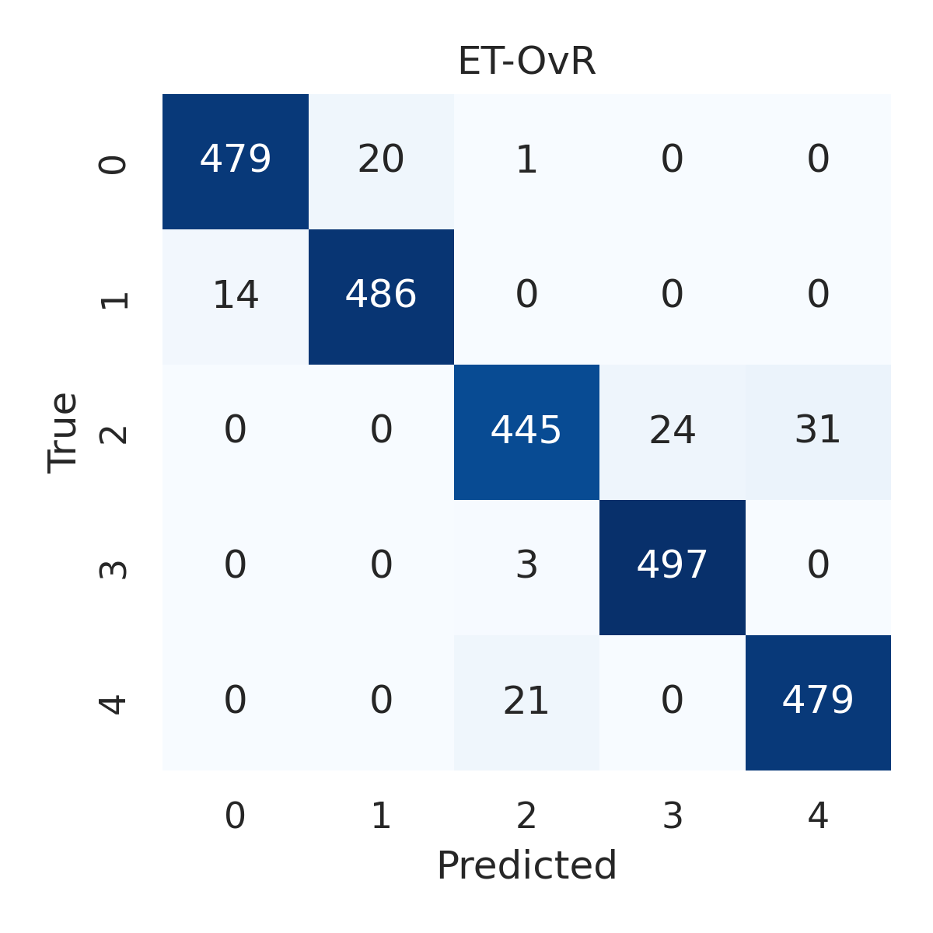

Combined ROC Curves
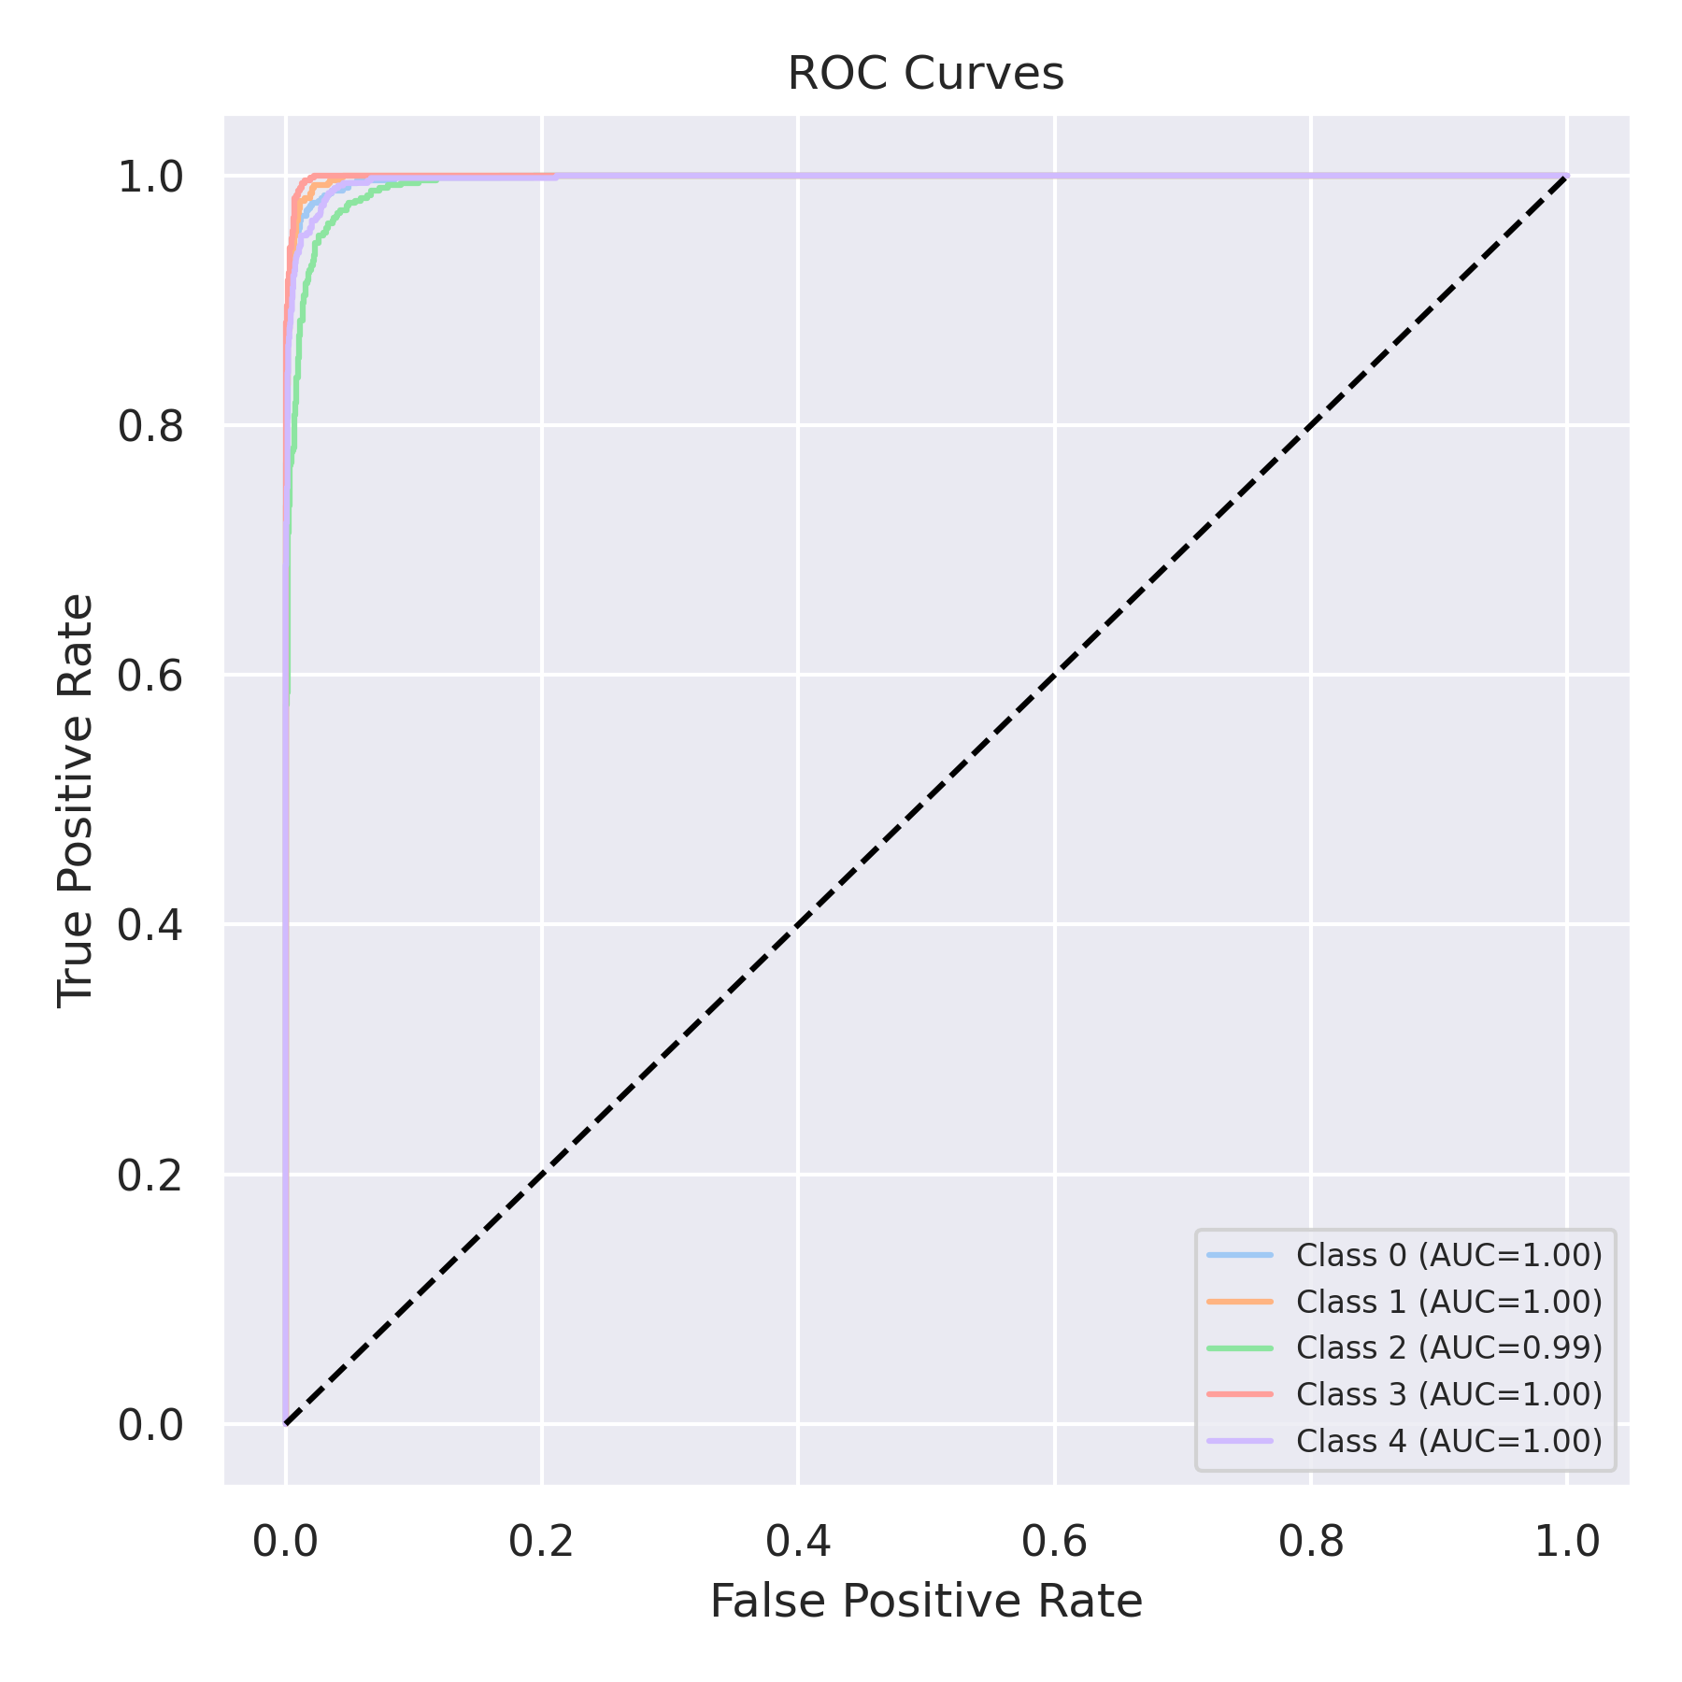

Evaluation: RF-OvR
Accuracy: 0.938
Precision: 0.9379315106522037
Recall: 0.938
F1 Score: 0.9374717442786401
Jaccard Index: 0.8833412368255383
Matthews CorrCoef: 0.9227410514480698
Cohen’s Kappa: 0.9225
Specificity: 0.9845
AUC: 0.9961159999999999
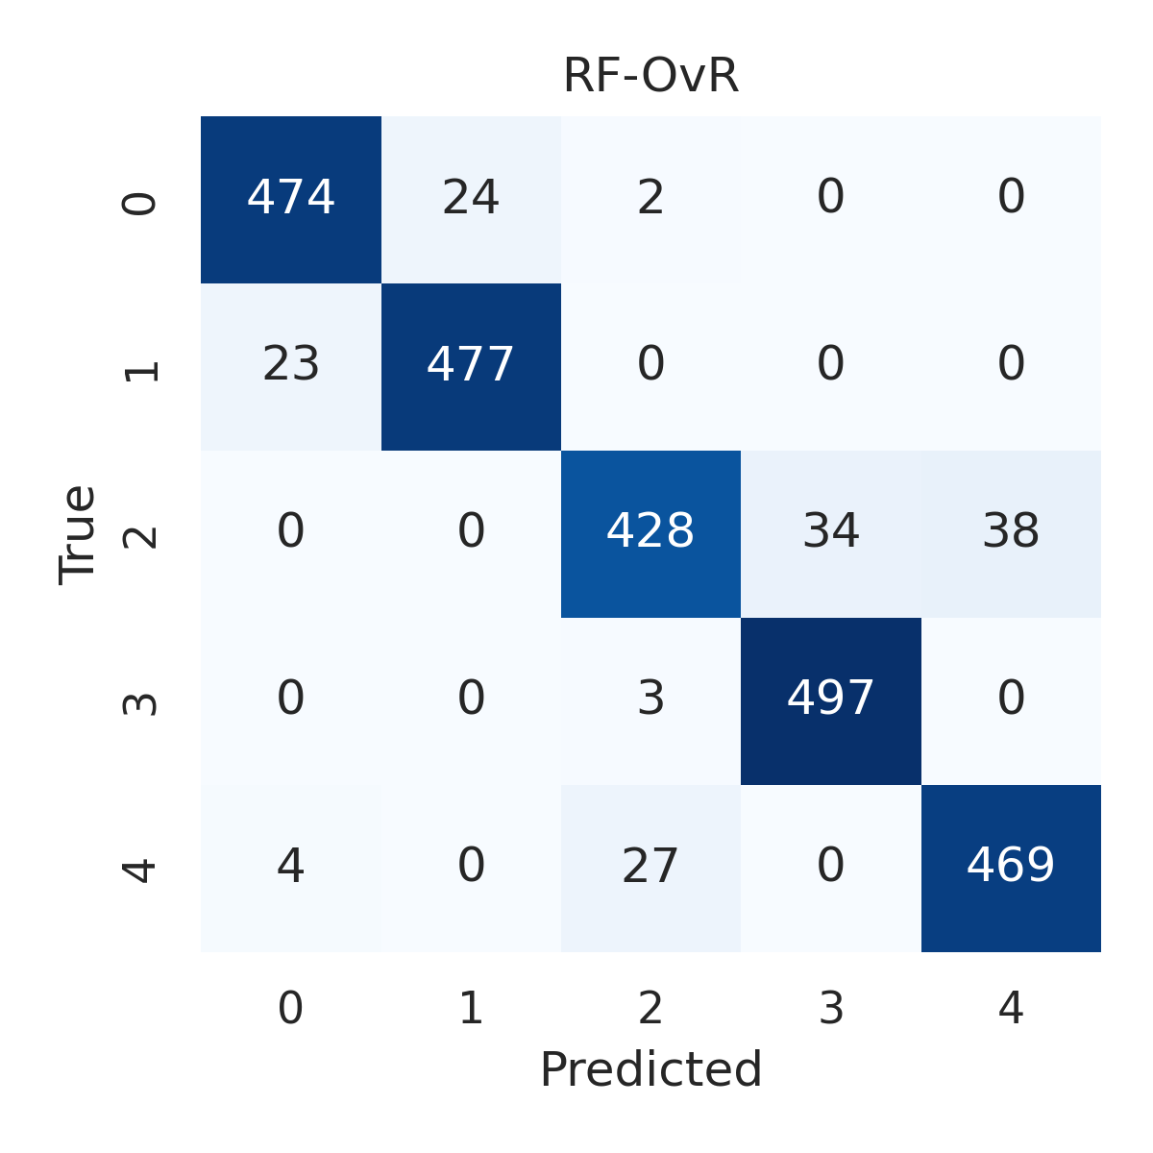

Combined ROC Curves
